🟩 THIS WEEK at KTS

It’s been a busy week at Kearns Technical Solutions—equal parts milestone and momentum.
We relaunched the KTS website following our migration to Ionos, giving our digital presence a sharper edge and a grounded feel. Alongside that, we filed our annual statement and accounts with Companies House, marking five years of KTS—a moment to reflect on the journey and the values that continue to shape our work.
Behind the scenes, we’ve been researching and refining the KTS newsletter, developing a new piping design specification that integrates enhanced use of AI tools, and laying the groundwork for a more agile, accountable team structure.


INDUSTRY REVIEW: Flatlines and Fault lines
What's been going on with UK industry in the last couple of weeks? Read on to find out about the latest in the Oil and Gas sector; Infrastructure and Nuclear; and a breakdown of the latest reporting from BP and Shell.
🛢️ Oil & Gas: Strategic Pressure and Policy Debate
No major new orders have emerged in UK oil, gas, or nuclear this quarter, reflecting a flat industrial outlook. Domestic production continues to decline, while operators remain cautious amid fiscal uncertainty and regulatory pressure. Energy security now leans heavily on imports from France, the Netherlands, Belgium, and Norway.
- INEOS, marking 50 years of the Forties Pipeline, warned the UK is “squandering its energy independence” under the 78% Energy Profits Levy (EPL).
- Petrofac entered administration in October—another blow to North Sea services.
- Wood Group’s ongoing struggles are covered later in depth.
🏗️ Infrastructure & Nuclear
- Centrica’s £1.3bn stake in Sizewell C remains a strategic anchor, but no new infrastructure contracts have surfaced recently.
- The UK Budget on 26 November may address energy taxation and unlock up to £40bn across 90 stalled projects—if the EPL is replaced early.

⚖️ Market Pulse
It’s not all doom and gloom: BP beat expectations despite lower profits, and Shell held firm with disciplined capital strategy. Both are actively reshaping portfolios in response to market pressures.

📈 MARKET WATCH

Distress Signals: Wood Group’s Value Collapse and the Sidara Bid
Foster Wheeler, a legacy Wood Group company won the Queen's Award for Enterprise 8 times
Wood Group’s valuation has collapsed by over 95% in the past decade — from a 2015–2017 peak near £4.4 billion to Sidara’s current offer of 30p per share, valuing the company at just £216 million.
Once a flagship of UK engineering. Now a cautionary tale of acquisition risk, governance failure, and strategic drift. We examine this sorry tale in some detail here, and see some last minute opportunity for the canny / brave / foolish investor.
🔍 Anatomy of the Collapse
- Heavy impairments In 2024, Wood Group recorded a £2.2bn goodwill write-down and £425m in exceptional charges - directly linked to its failure to extract value from the acquisition of Amec Foster Wheeler in 2017.
- Consistent losses Wood Group has posted a profit only once since 2016. In 2024, it recorded a $2.76bn pre-tax loss, despite a $6.5bn order book. Winning orders while running at a loss is easy — but unsustainable.
- Material weaknesses in financial controls Long-standing governance issues relating to financial controls came to a head in 2024, triggering delayed accounts and a months-long suspension of share trading — lifted only in early November.
- Leadership inertia A senior team remained in place through years of underperformance, impairments, and strategic drift — with limited visible accountability.
🌤️ Silver Lining for the Brave Investor
For the brave investor, there is a potential silver lining in this dark cloud. The Sidara offer now presents a rare merger arbitrage opportunity, with a potential 65% upside for short-term investors.

💼 Sidara’s Offer: Timeline and Signals
- Offer agreed: August 2025
- Credit extension approved: 23 October
- Accounts published: Late October
- Trading resumed: 6 November
- Shareholder vote: Expected week of 17 November
The board has unanimously recommended the deal. With credit approval secured and accounts published, the risk of collapse has receded — though not vanished.
📉 Why Some Investors Are Still Selling
- Uncertainty fatigue — years of volatility have eroded trust
- Liquidity preference — some prefer cash now over waiting for the offer to complete
- Residual risk — regulatory or procedural hiccups could still derail the deal
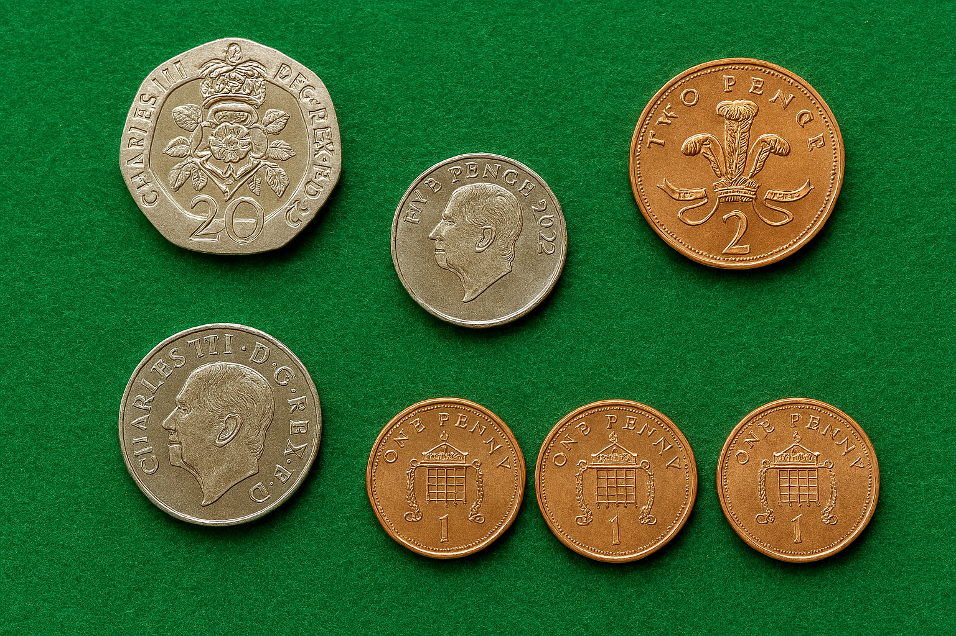
📊 Arbitrage Snapshot
- Current share price: ~23.3p
- Offer price: 30p
- Potential upside: ~30%
- Timeline: ~2–4 weeks
🧨 Risks to Watch
- Deal collapse — would likely trigger a sharp drop in share price
- Delays — could erode arbitrage value
Yet the offer is backed by credit approval, board recommendation, and published accounts — the prerequisites for completion.
A year ago, Sidara were offering 230p per share. Sidara didn’t just dodge a bullet then — they sidestepped a cannonball. Now, however, it looks like they are acquiring Wood now at a steep discount, post-collapse.
🏗️ What’s Still Working at Wood
Despite its financial collapse, Wood retains core strengths:
- $6.5bn order book — up 5.9% year-on-year
- Technical credibility — in complex engineering and energy transition
- Global client base — still awarding work despite reputational drag
- Sidara’s capital injection — $450m pledged to stabilise operations
For a variety of reasons, I just don’t see the offer being rejected.

🕰️ Delay Risk: The Arbitrage Erosion Curve
- Shareholder Vote Slippage Procedural hiccups — such as incomplete proxy submissions or legal challenges — could push the vote beyond November. Delay risk: Low, but not zero.
- Regulatory or Legal Review While no formal antitrust or regulatory blocks are expected, last-minute scrutiny (especially around Sidara’s offshore assets) could stall completion. Delay risk: Moderate.
- Documentation or Settlement Lags Even after approval, the mechanics of settlement — share delisting, cash distribution, and integration — can take 2–4 weeks. Poor communication could spook short-term arbitrage holders expecting a quick exit.
Downside risk: If the deal collapses, Wood’s share price could fall back toward 10–12p, wiping out gains.
🪵 Final Word
After years of losses, maybe it is still worth a shot at squeezing some value out of the Wood.


🐾 BUZZ'S MATHS CORNER: Stellar Parallax
“Why I Tilt My Head (and How It Helps Measure Stars)”
You know how I sometimes tilt my head when you call my name? That’s not just to look cute — it’s to get a better angle. And believe it or not, that’s how astronomers measure the distance to stars.
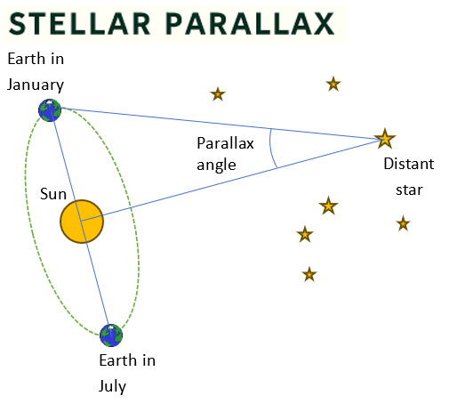
It’s called stellar parallax — a fancy term for what happens when you look at something from two different spots and it seems to shift. Try this: hold out a treat (please) and look at it with one eye, then the other. See how it jumps? That’s parallax.
Now imagine Earth doing the same thing. It orbits the Sun, so six months apart, it’s on opposite sides of its path — like me standing on the left side of the garden in January, then the right side in July. If I stare at a nearby lamppost (or star), it’ll look like it’s moved a bit against the background trees (or distant stars). That tiny shift — measured in arcseconds — tells you how far away the lamppost is.

Astronomers use this to calculate stellar distances with trigonometry. I use it to calculate how far I need to leap to reach the biscuit tin.
So next time you see me squinting at the sky, I’m not just chasing pigeons. I’m mapping the cosmos.
— Buzz, Chief Parallax Officer at KTS
And here’s how astronomers use it:
- The baseline is the diameter of Earth’s orbit (2 AU).
- The angle is the parallax angle (half the total shift).
- The opposite side is the apparent shift in the star’s position.
- The adjacent side is the distance to the star.
This forms a right triangle, allowing us to use basic trigonometry:
$$tan\left(p\right)=\frac{1 AU}{d}$$
Where p is the parallax angle and d is the distance to the star and 1 AU is the astronomical unit, equal to the average distance between the earth and the sun.
Sounds easy? Actually, its practical limits depend on instrument precision, and it wasn’t until the 1830’s that the method was first successfully used to measure the distance to a star.
And it has practical limitations:
- Even for nearby stars, parallax angles are less than 1 arcsecond. These are tiny angles and difficult to measure.
- And, due to atmospheric distortion, observations made from ground-based observatories are unreliable above about 100 parsecs. (That’s still quite far, though).
- Space-based telescopes have extended reliable measurements to several thousand parsecs (10,000–30,000 light-years).
If you want to measure the distance to anything outside the Milky Way, I’m afraid tilting your head won’t cut it. You’ll need a very long tape measure.

🔧 AI Update: KTS Issues new Piping Design Specification
Kearns Technical Solutions is proud to publish the Piping Discipline Specification – PIP-001-REV0, formalizing our approach to team structure, digital integration, and AI-enabled workflows across the piping lifecycle.
This document sets out:
- Defined roles and reporting lines via the RRM-001 matrix
- AI-enhanced protocols for line list validation, routing, and clash detection
- Smart MTO and MR generation, predictive maintenance, and digital twin readiness
- Clear authorship, metadata compliance, and version control
📄 KTS-PIP-001-REV0
This marks a key milestone in KTS’s commitment to clarity, accountability, and modern engineering practice.

